**Client: Scalawags Veterinary Clinic**



**Kevin Yang**

**John Beguhl**

**Jisung Woo**

**Scalawags Veterinary Clinic**

***Section 1: Transaction Overview***

1. ***BEFORE (CLIENT AFTER-HOUR EMERGENCY)***

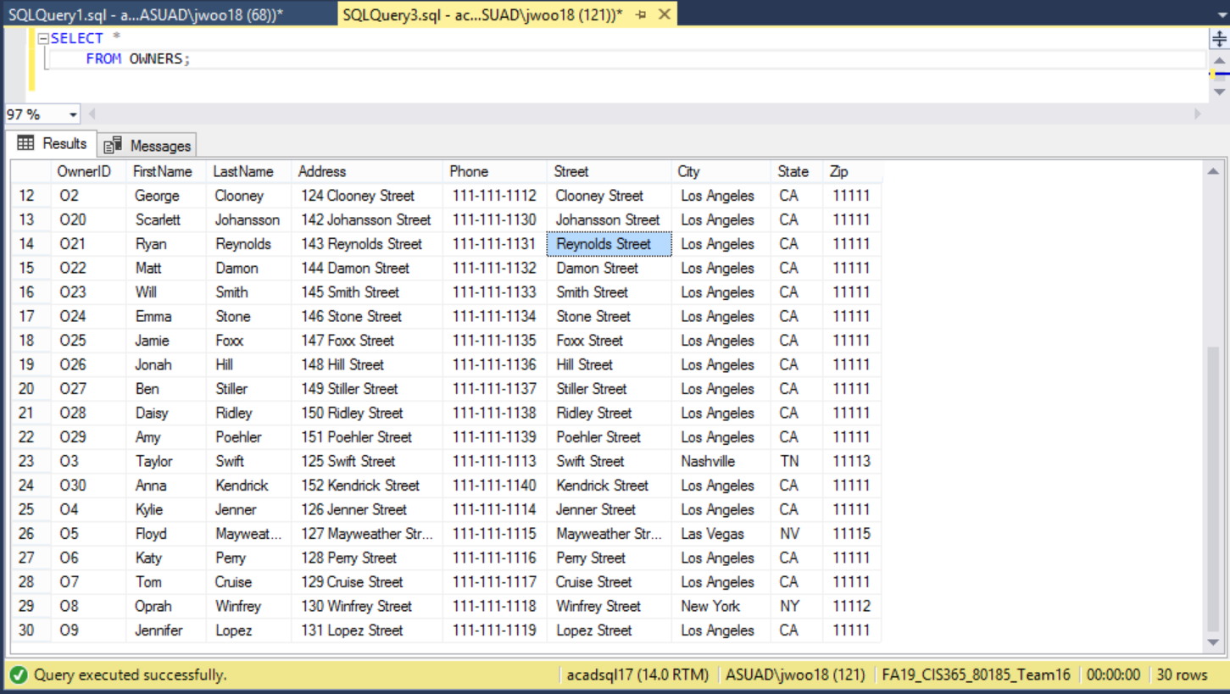

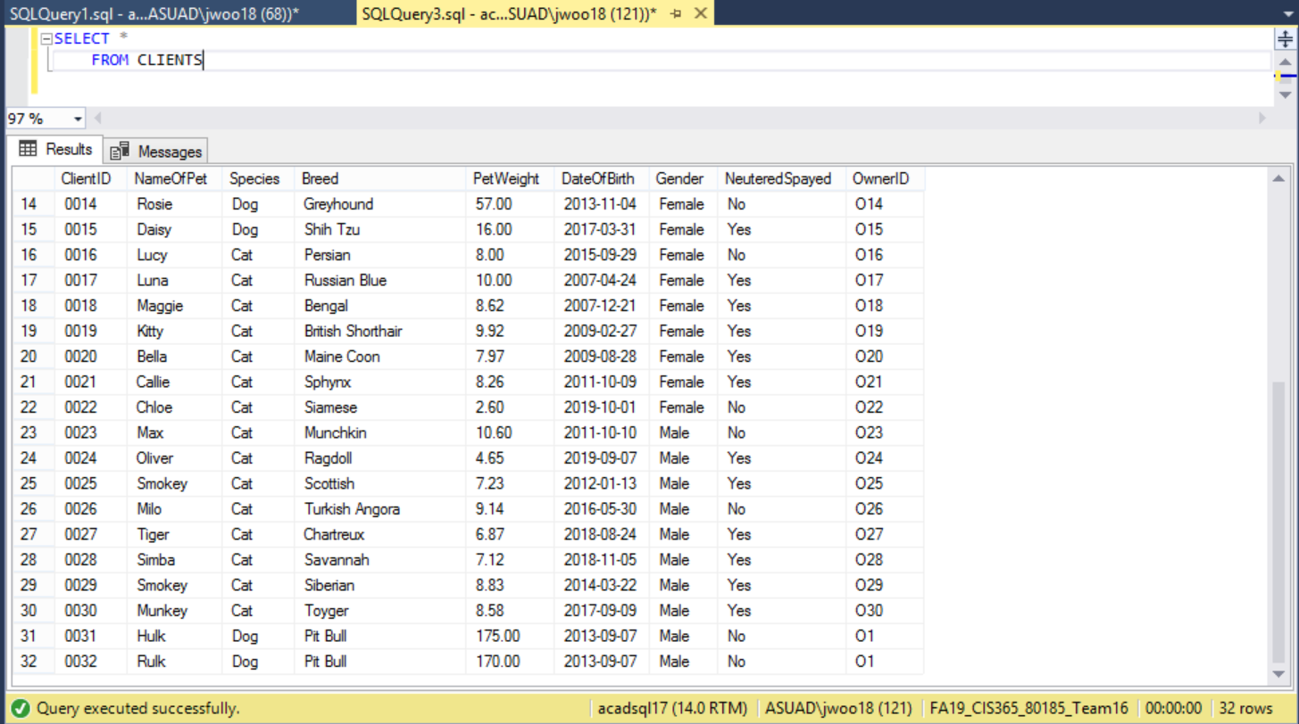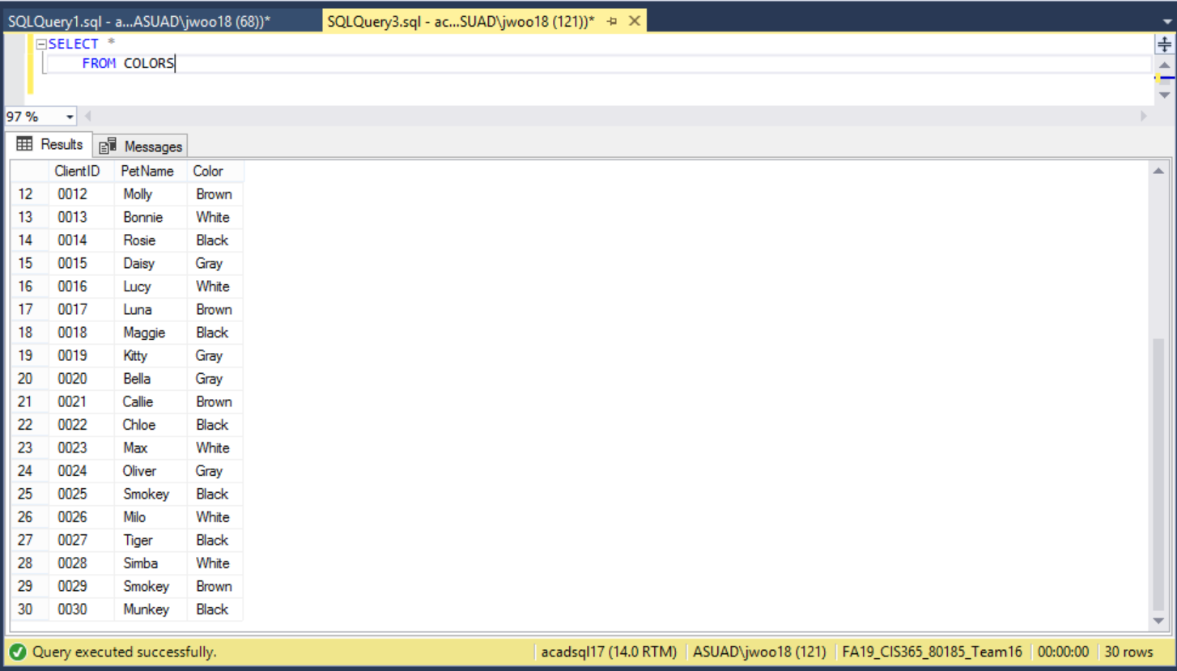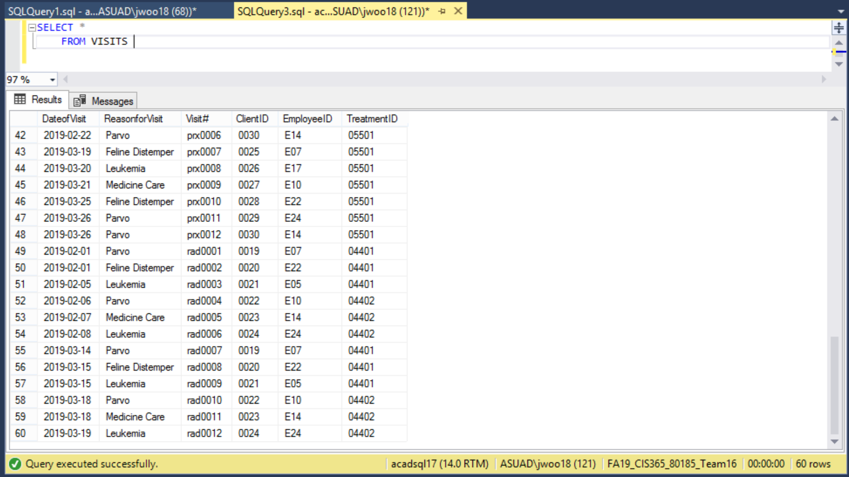

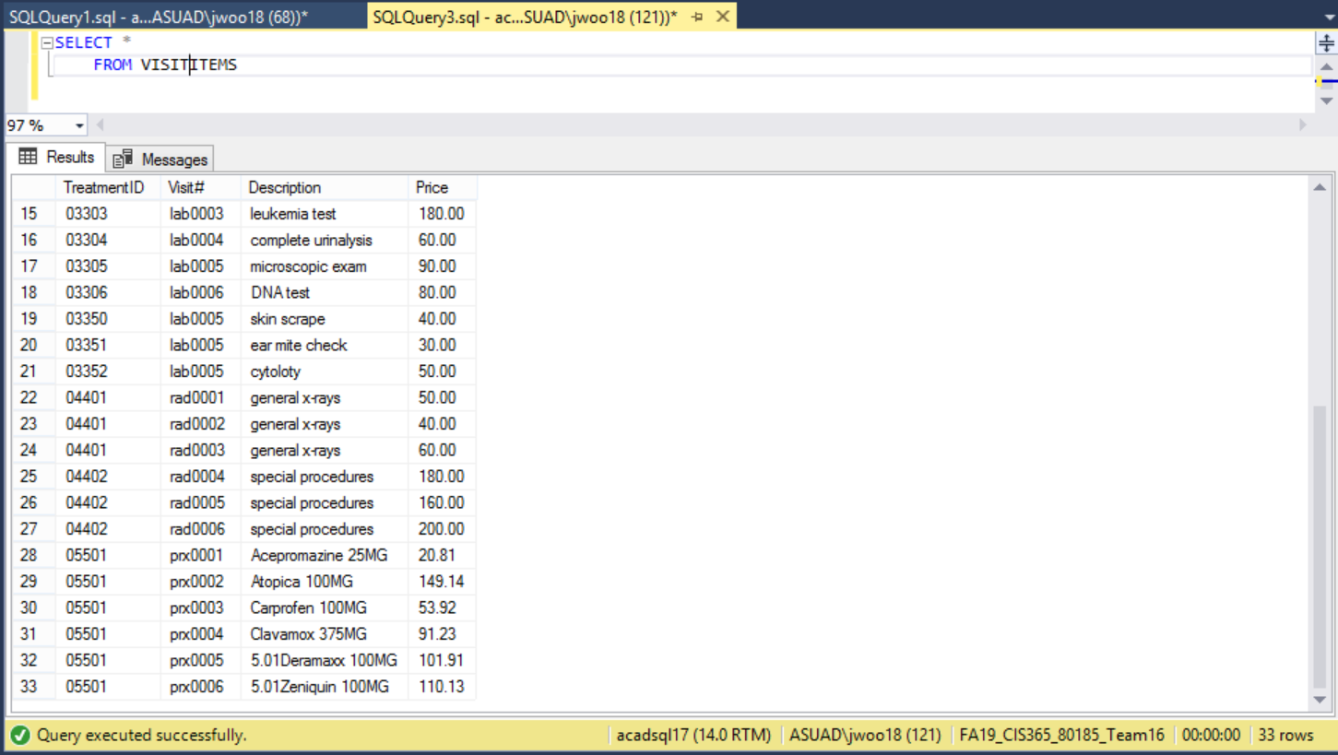

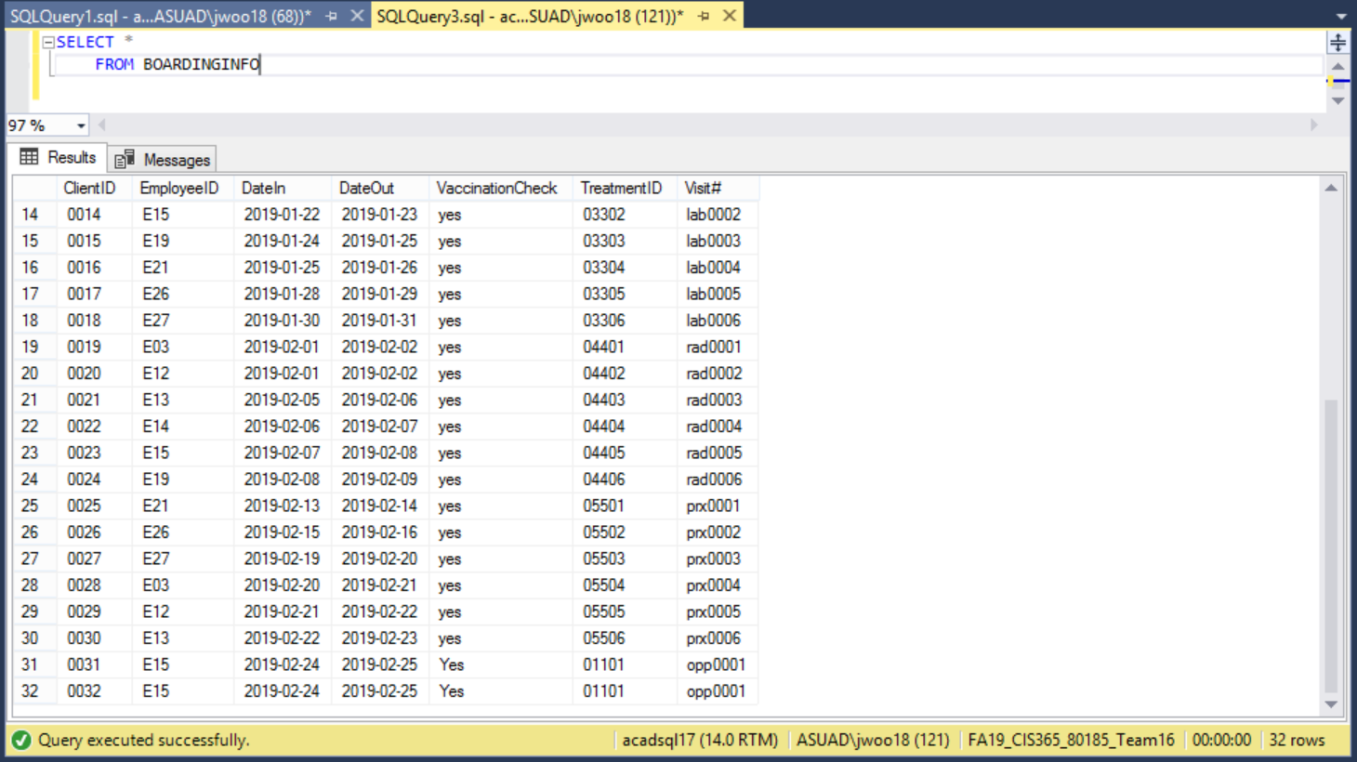

***AFTER (AFTER-HOUR EMERGENCY)***

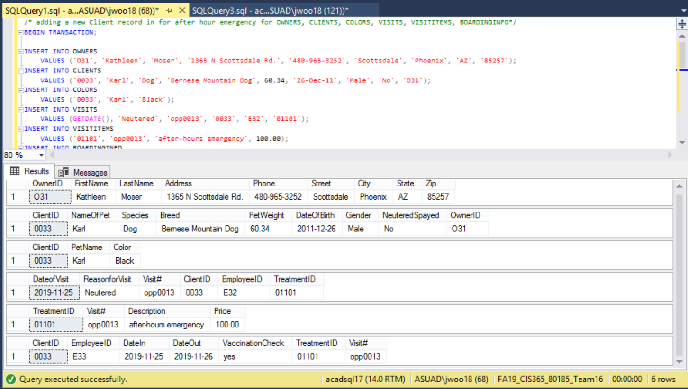

***2. BEFORE (NEW VET)***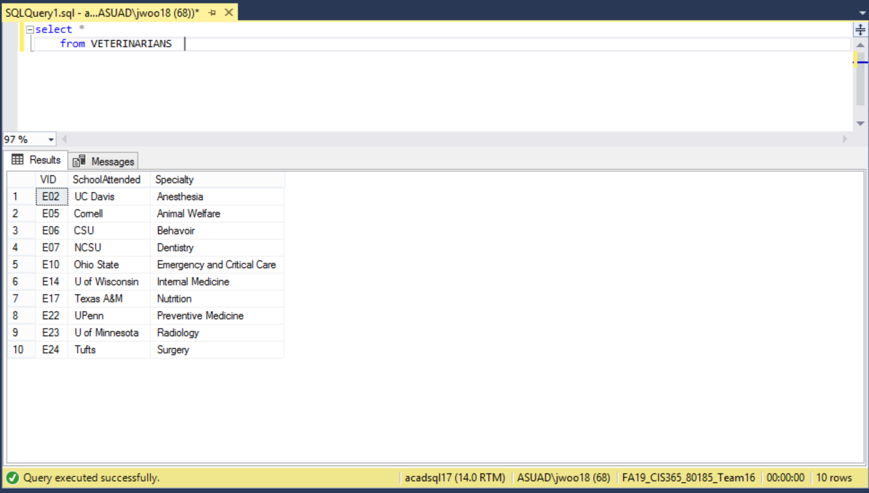 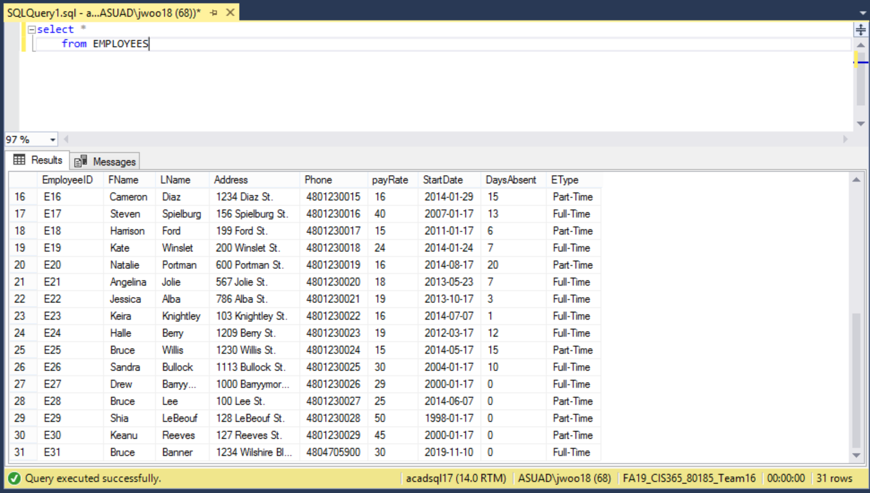 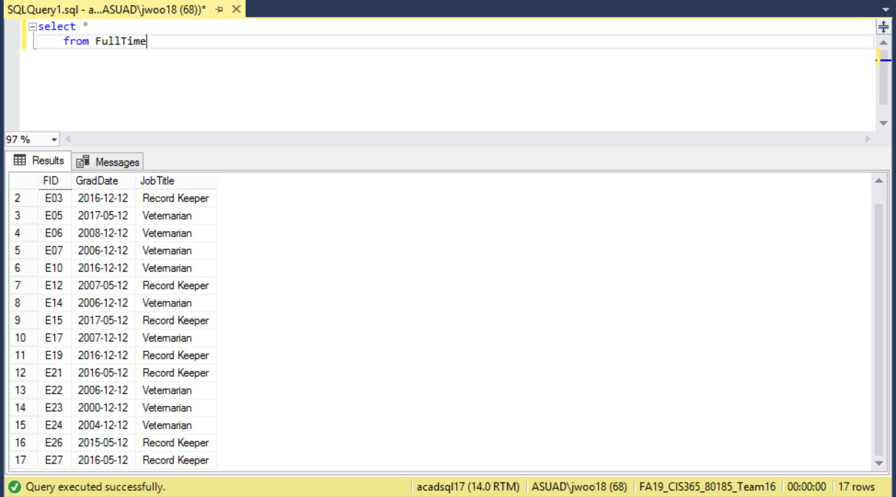

***AFTER (NEW VET)***

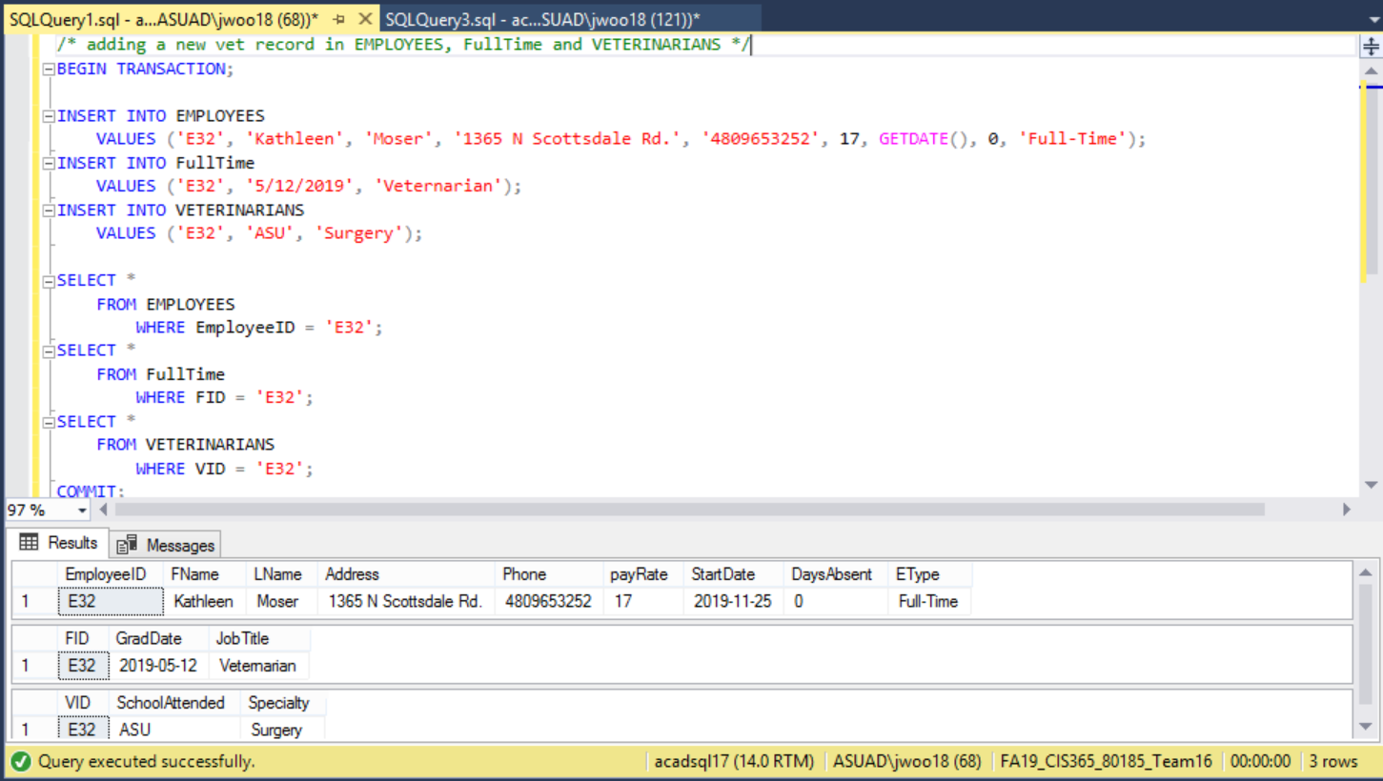

***Section 2: Triggers/Stored Procedures Overview***

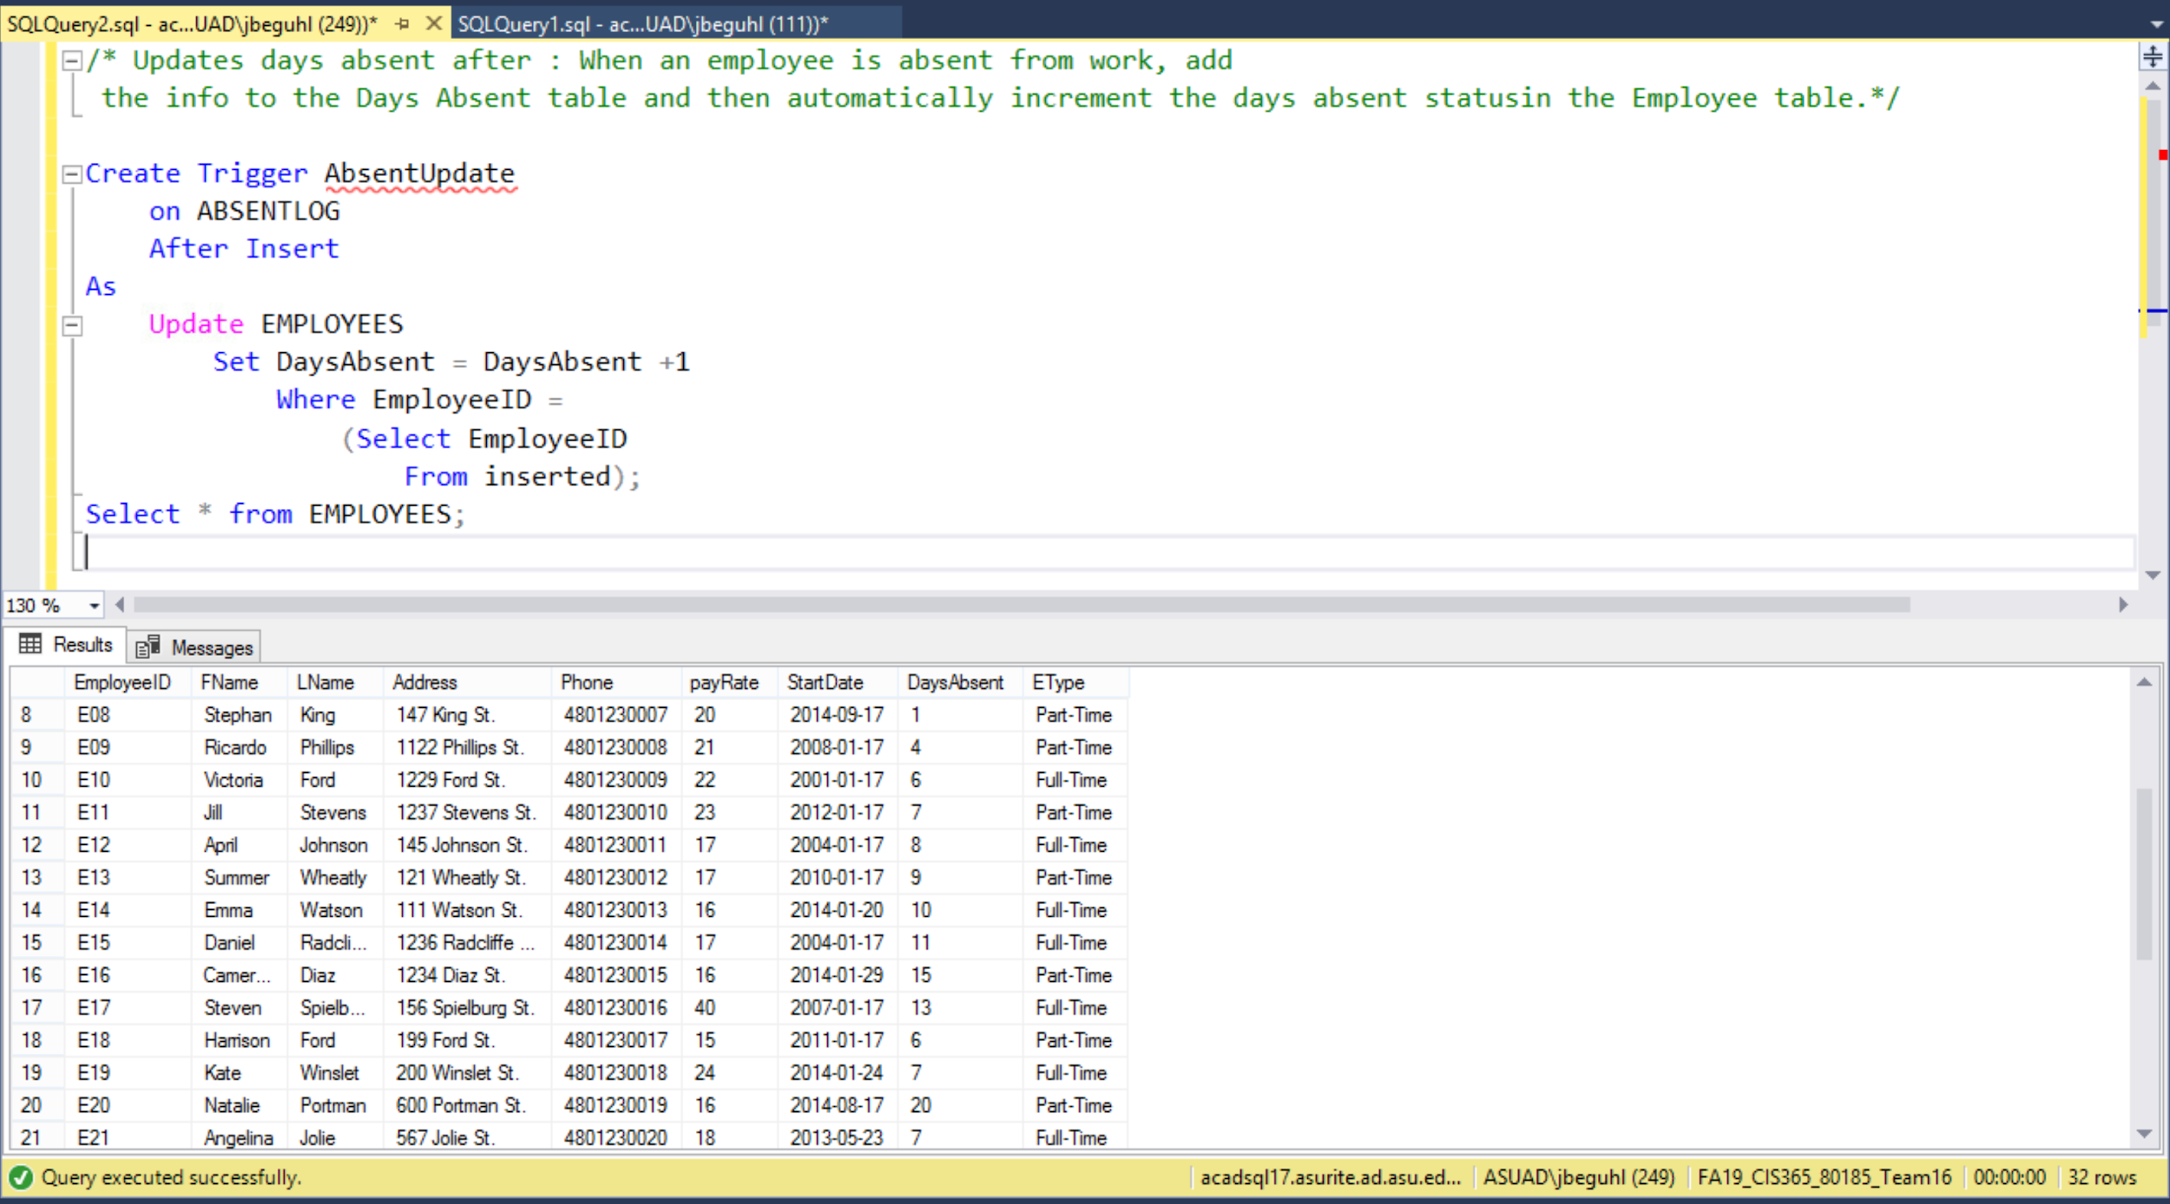

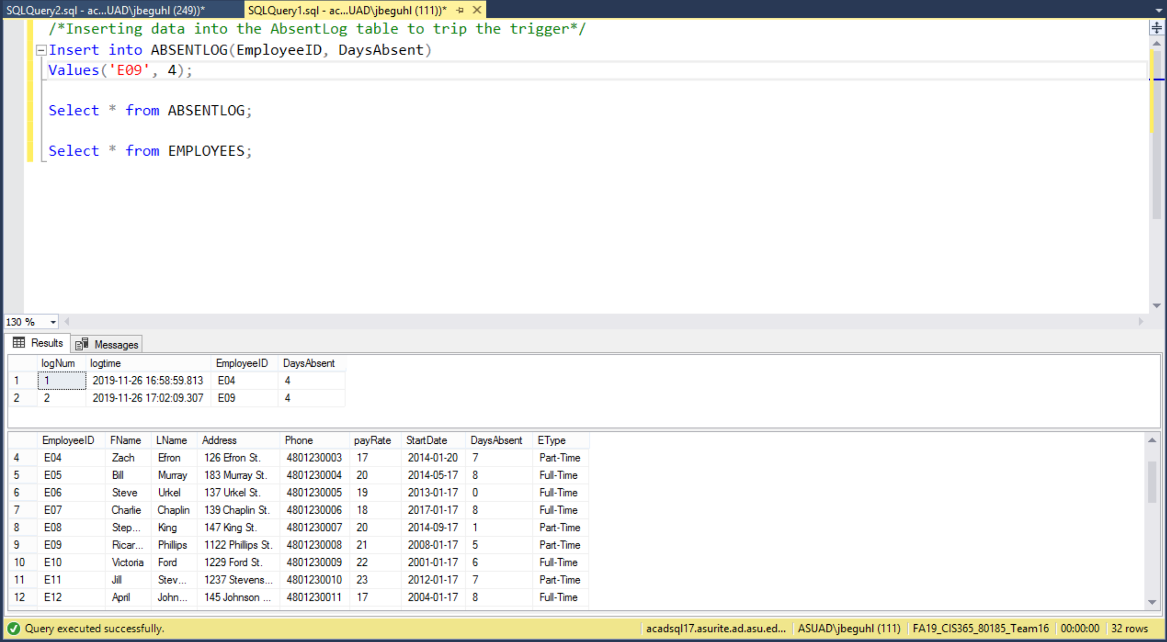

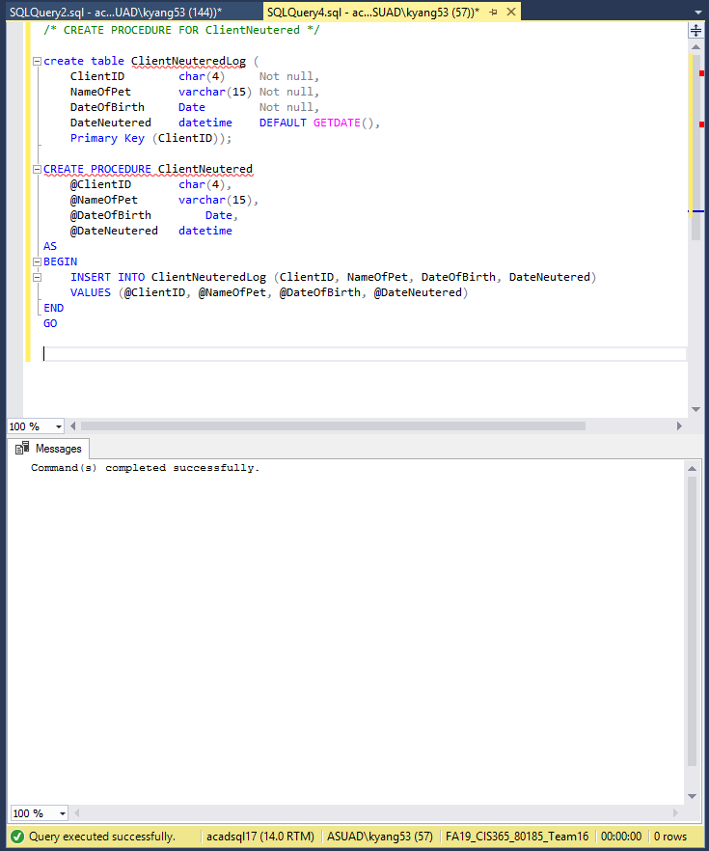

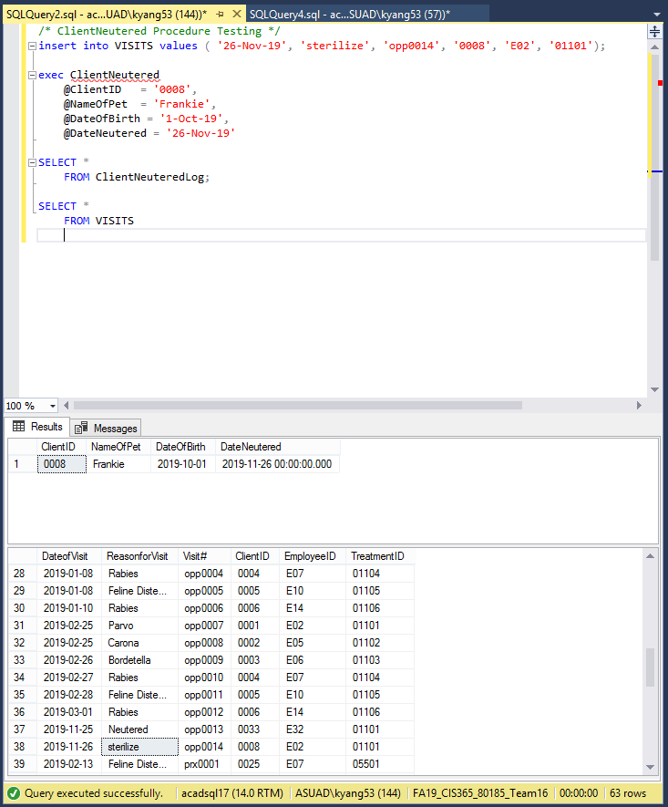

***Section 3: Indexes***

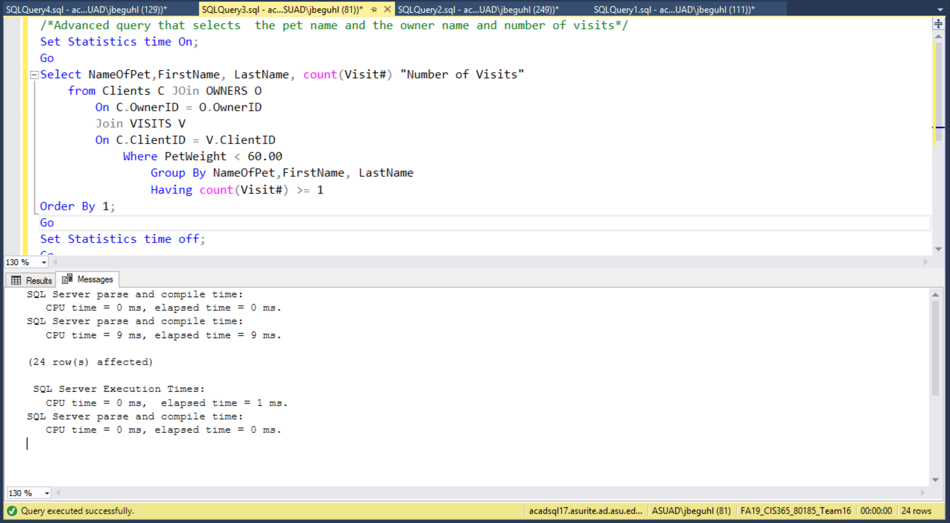

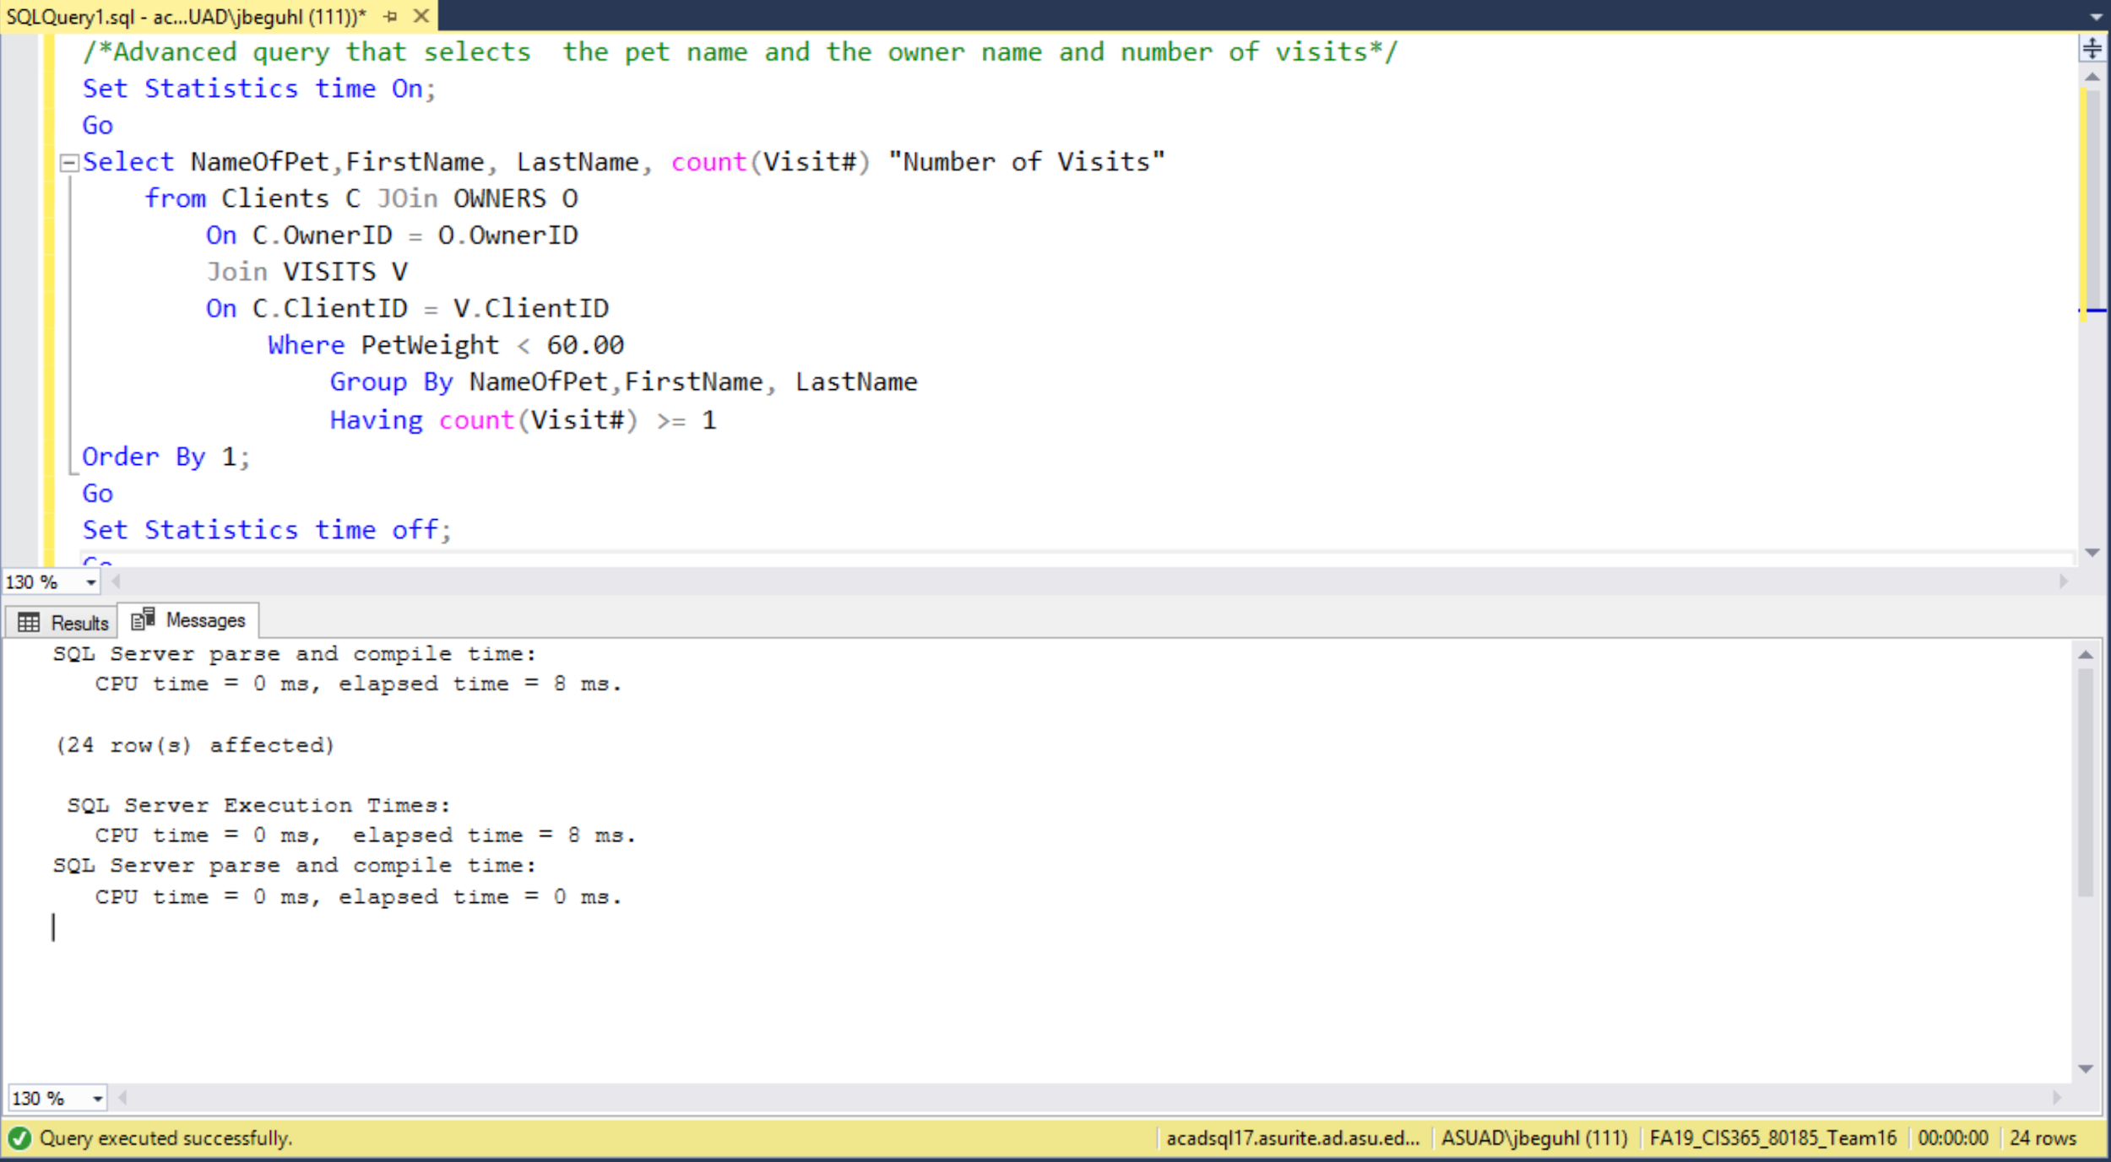

***Section 4: Analytics Dashboard Overview***

* ***Dog’s Visits***

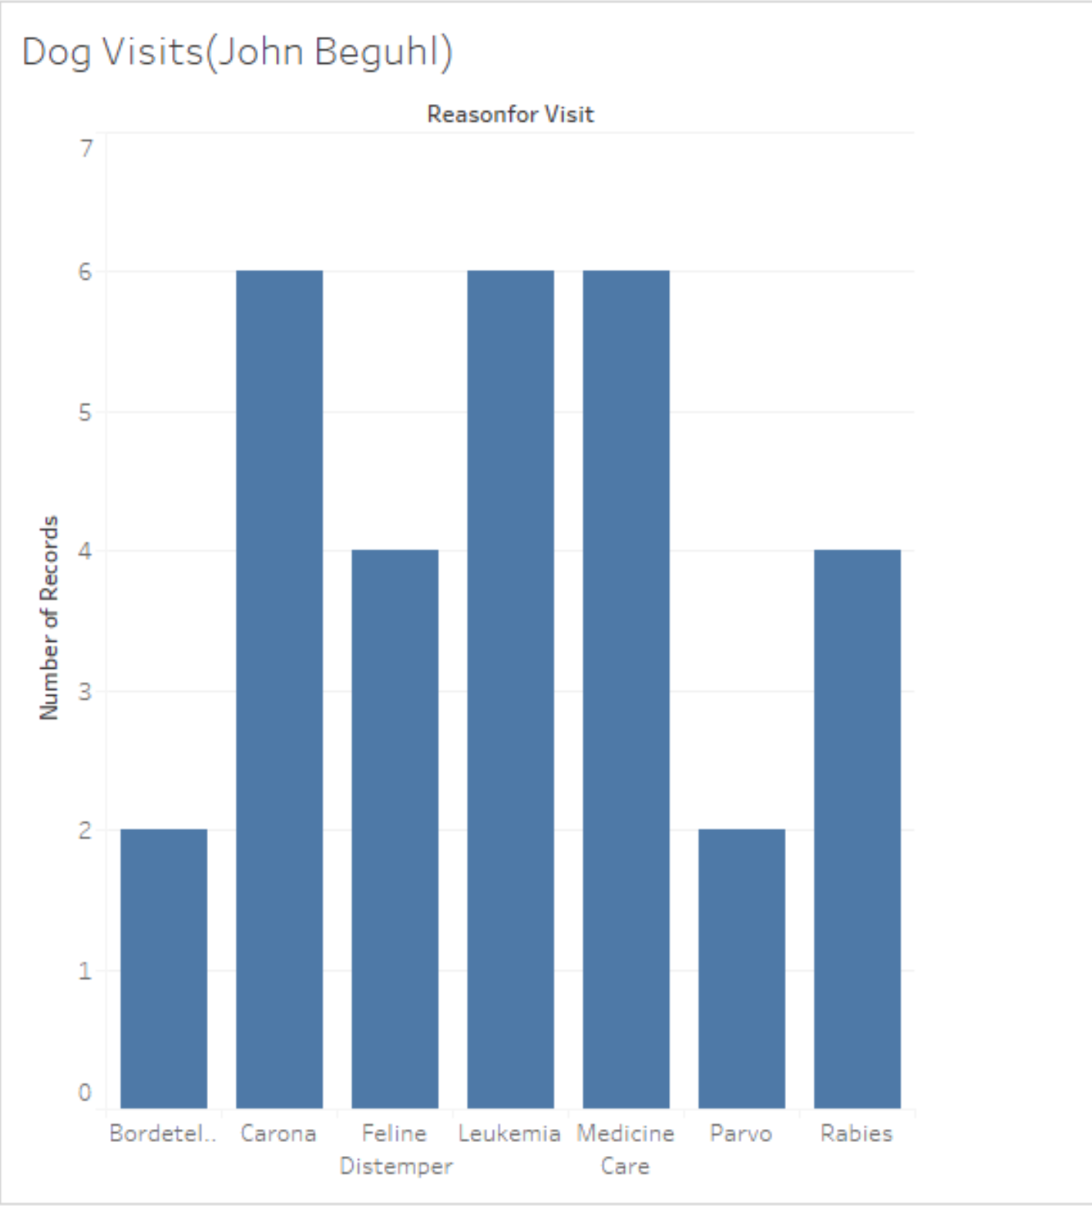

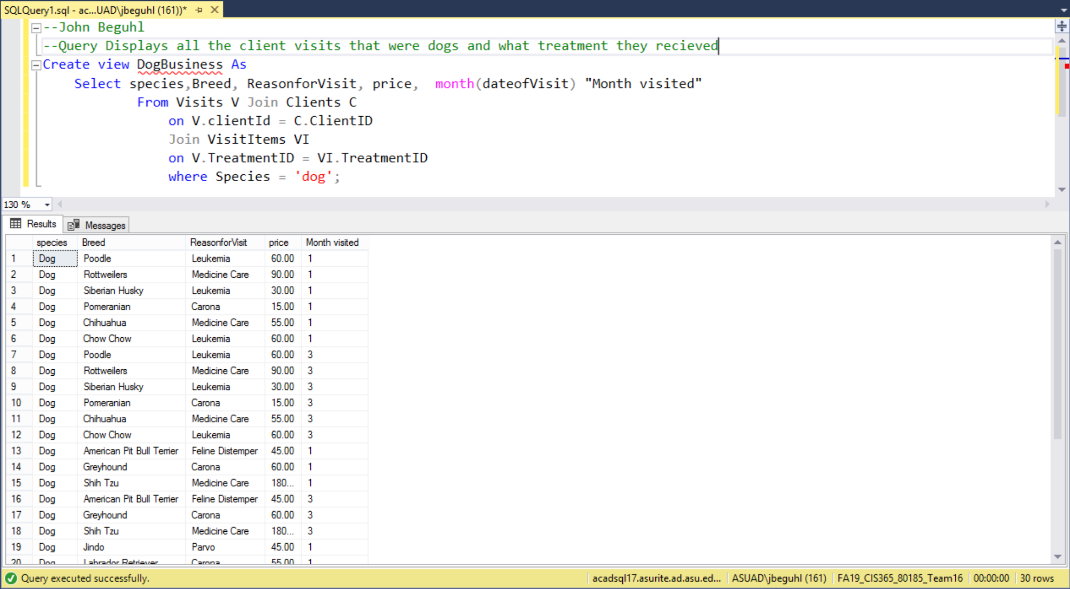

* ***Cat’s Visits***

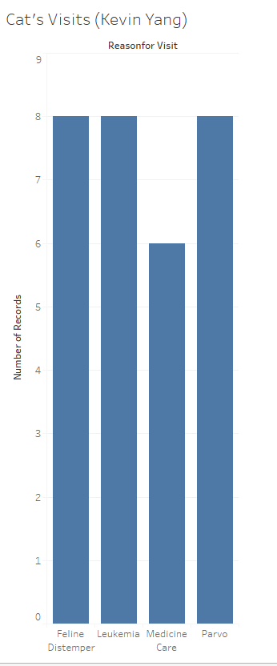

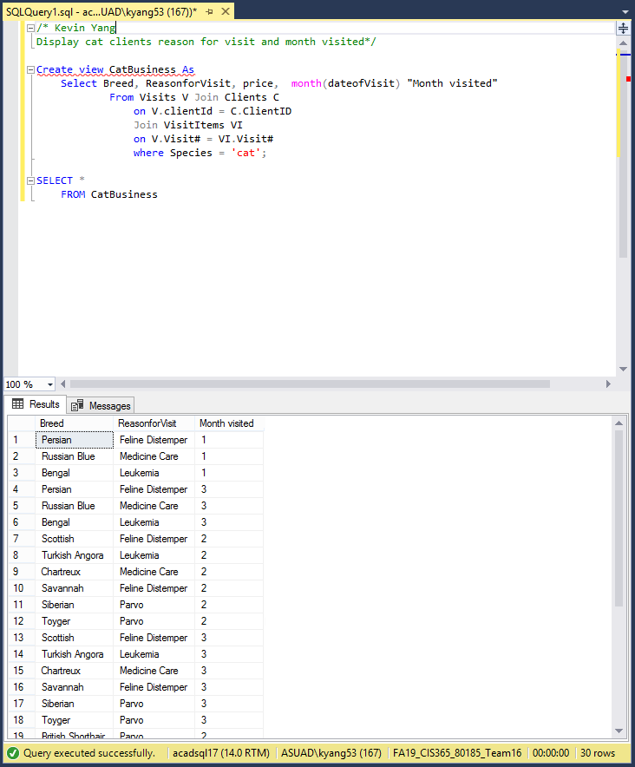

* ***Total Business***

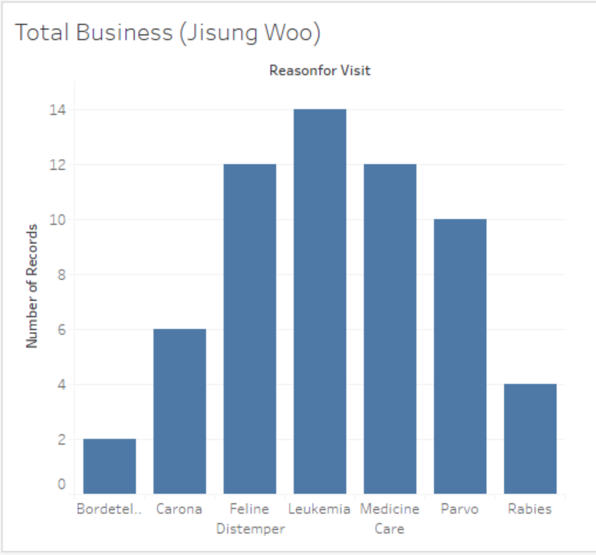

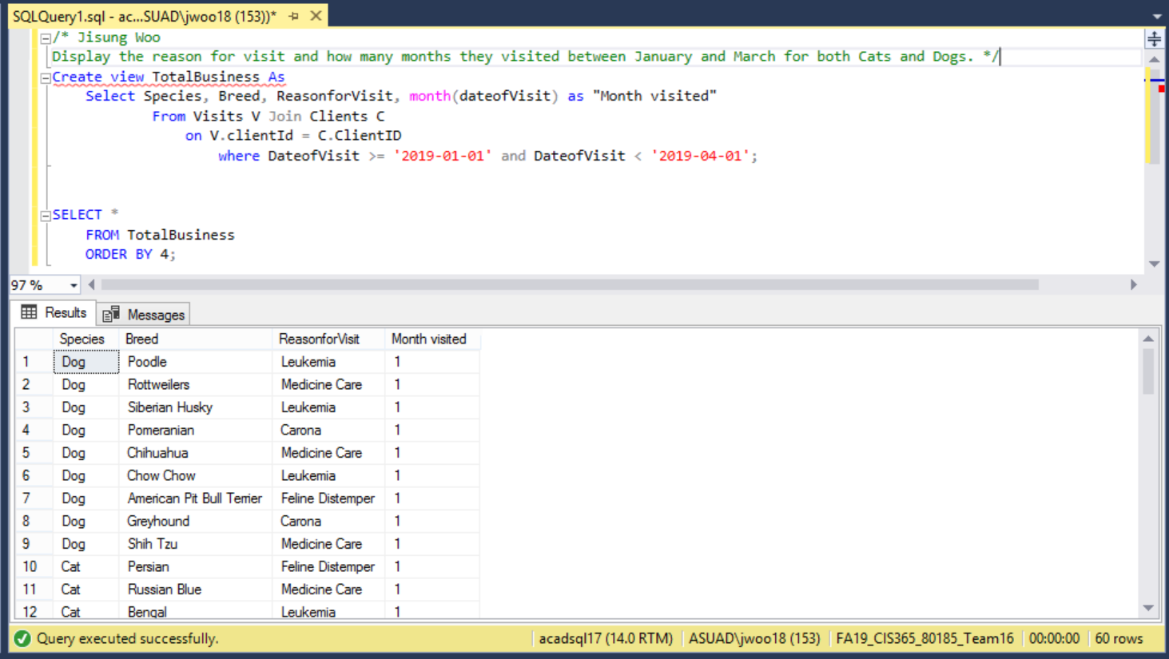

Dashboard of our story

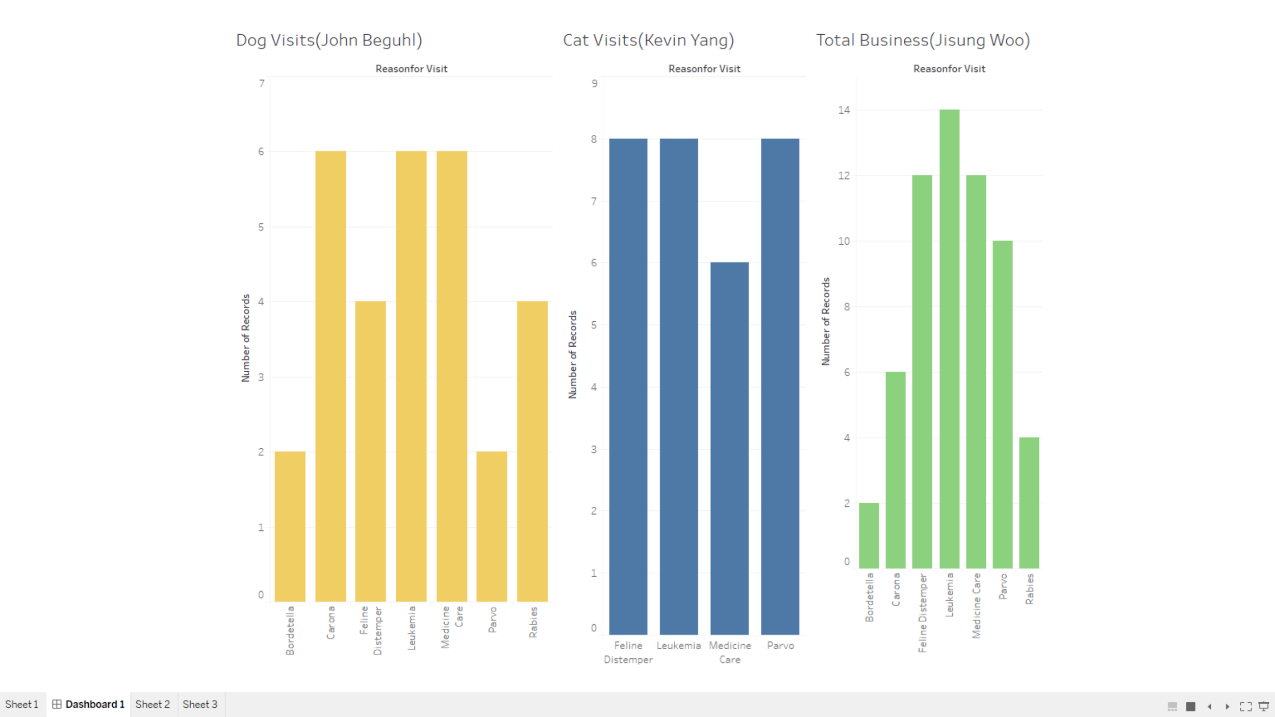

***Meeting Agenda***

**Date & Time: 11/12/2019**

**Team Meeting for: Team 16: Sparky’s Finest**

**Client’s Name: Veterinary Clinic**

**Team members in attendance:**

**1. Jisung Woo (Head) 2. John Beguhl**

**Team members Absent:**

**1. Kevin Yang**

**Meeting Objective:** Discuss and plan metadata specifications for all project database tables.

**Agenda: (CHANGE AS NECESSARY!)**

* Brainstorm IC10 Story ideas

|  |  |  |
| --- | --- | --- |
| **Action Item** | **Assigned To** | **Due Date** |
| Master Visualization (Tableau) | Everyone | 11/14/2019 |

**Time meeting ended: *2:45 PM***

**Date and time of next meeting: *11/14/2019 4:30 PM***

*==============================================================================*

**Date & Time: 11/14/2019**

**Team Meeting for: Team 16: Sparky’s Finest**

**Client’s Name: Veterinary Clinic**

**Team members in attendance:**

**1. Jisung Woo (Head) 2. John Beguhl**

**3. Kevin Yang**

**Meeting Objective:** Discuss and plan metadata specifications for all project database tables.

**Agenda: (CHANGE AS NECESSARY!)**

* Discussing indexes, see if everyone understood indexes

|  |  |  |
| --- | --- | --- |
| **Action Item** | **Assigned To** | **Due Date** |
| Go over indexes and understand | Everyone | 11/19/2019 |

**Time meeting ended: *2:45 PM***

**Date and time of next meeting: *11/21/2019 4:30 PM***

*==============================================================================*

**Date & Time: 11/21/2019 & 4:30 PM**

**Team Meeting for: Team 16: Sparky’s Finest**

**Client’s Name: Veterinary Clinic**

**Team members in attendance:**

**1. Jisung Woo (Head) 2. John Beguhl**

**3. Kevin Yang**

**Meeting Objective:** Discuss and plan metadata specifications for all project database tables.

**Agenda: (CHANGE AS NECESSARY!)**

* Fix the scripts for Visualization Views
* Start on Indexes

|  |  |  |
| --- | --- | --- |
| **Action Item** | **Assigned To** | **Due Date** |
| Master Indexes and Triggers | Everyone | 11/23/2019 |

**Time meeting ended: *5:30 PM***

**Date and time of next meeting: *11/24/2019 3:00 PM***

*==============================================================================*

**Date & Time: 11/24/2019 & 3:00 PM**

**Team Meeting for: Team 16: Sparky’s Finest**

**Client’s Name: Veterinary Clinic**

**Team members in attendance:**

**1. John Beguhl(Chair) 2. Jisung Woo**

**3. Kevin Yang**

**Meeting Objective:** Discuss and plan metadata specifications for all project database tables.

**Agenda: (CHANGE AS NECESSARY!)**

* Fix the scripts for Visualization Views
* Start on Indexes

|  |  |  |
| --- | --- | --- |
| **Action Item** | **Assigned To** | **Due Date** |
| Finish Milestone 5 | Everyone | 11/24/2019 |
| Finish IC-10 & 11 | Everyone | 11/24/2019 |

**Time meeting ended: 6:00pm**

**Date and time of next meeting: *11/25/2019 4:00 PM***

*==============================================================================*

**Date & Time: 11/25/2019 & 3:00 PM**

**Team Meeting for: Team 16: Sparky’s Finest**

**Client’s Name: Veterinary Clinic**

**Team members in attendance:**

**1. Jisung Woo (Chair) 2. John Beguhl**

**3. Kevin Yang**

**Meeting Objective:** Discuss and plan metadata specifications for all project database tables.

**Agenda: (CHANGE AS NECESSARY!)**

* Finish working on Procedure
* Start and finish transaction

|  |  |  |
| --- | --- | --- |
| **Action Item** | **Assigned To** | **Due Date** |
| Finish Procedure and Transaction from Milestone 5 | Everyone | 11/24/2019 |

**Time meeting ended: 6:00pm**

**Date and time of next meeting: *11/26/2019 4:30pm***

*==============================================================================*

**Date & Time: 11/26/2019 & 4:30 PM**

**Team Meeting for: Team 16: Sparky’s Finest**

**Client’s Name: Veterinary Clinic**

**Team members in attendance:**

**1. Jisung Woo (Chair) 2. John Beguhl**

**3. Kevin Yang**

**Meeting Objective:** Discuss and plan metadata specifications for all project database tables.

**Agenda: (CHANGE AS NECESSARY!)**

* Finish working on Procedure
* Finalize M5
* Submit M5 and in class exercise

|  |  |  |
| --- | --- | --- |
| **Action Item** | **Assigned To** | **Due Date** |
| Finish Procedure | Everyone | 11/26/2019 |
| Edit and finalize Team16-M5.pdf | Jisung | 11/26/2019 |
| Edit and finalize Team16-M5.txt | John | 11/26/2019 |
| Submit M5, IC10 & IC11 | Kevin | 11/26/2019 |

**Time meeting ended: 5:45pm**

**Date and time of next meeting: *11/28/2019 TBA***

*Individual Journal Entries*

|  |  |  |
| --- | --- | --- |
| ***Team Member Name: Jisung Woo*** | | |
| ***Date of Work Performed*** | ***Description work performed*** | ***Time Spent on Work Performed (HRS)*** |
| 8/29/2019 | Gathered Team's information | 0.2 |
| 8/29/2019 | Created Milestone 1 Google Drive Folder and Document | 0.1 |
| 9/7/2019 | Answered 15 questions from "100 getting to know you questions" | 1 |
| 9/8/2019 | Wrote Yannan Zhu's introduction | 1 |
| 9/10/2019 | Had a team meeting (arrived late) | 0.17 |
| 9/10/2019 | Created Title Page and researched for suitable logo | 0.5 |
| 9/10/2019 | Created multiple documents, Agenda, Individual Journal Entries, Logo ideas, and resource Histogram | 2 |
| 9/11/2019 | Declared for chair position | 0.02 |
| 9/11/2019 | Edited Meeting Agenda for both 8/29/2019 and 9/10/2019 | 1.5 |
| 9/11/2019 | Updated and uploaded my resume and pictures | 0.75 |
| 9/11/2019 | Edited Team Profile section on Milestone one | 0.25 |
| 9/11/2019 | Updated Resource Histogram | 0.1 |
| 9/12/2019 | Reviewed and Signed Team Agreement | 0.2 |
| 9/13/2019 | Complete "when to meet" website | 0.083 |
| 9/14/2019 | Finalized Meeting Agendas | 0.5 |
| 9/14/2019 | Made sure if all documents were in correct format and correct font | 0.05 |
| 9/14/2019 | Added consequences section on Team Agreement document | 0.17 |
| 9/15/2019 | Finished "Assigned Tasks" section on Milestone 1 | 0.017 |
| 9/15/2019 | Wrote my initials on the pages that I've created and/or worked on | 0.17 |
| 9/15/2019 | Gave team warning on what is still missing from certain people and need in better communication | 0.17 |
| 9/18/2019 | Team Meeting | 0.5 |
| 9/18/2019 | Re-create Individual Journal Entries | 0.083 |
| 9/18/2019 | Re-create Unedited Version of Meeting Agenda | 0.083 |
| 9/21/2019 | Milestone 2 Outline on my own | 0.5 |
| 9/23/2019 | Team Meeting | 1.25 |
| 9/23/2019 | Created and edited "Questions for Office Hour/Tutoring Center" | 0.167 |
| 9/24/2019 | Create my own draft of EERD | 0.5 |
| 9/25/2019 | Create a separate document and upload EERD (because I won't be able to attend the meeting) | 0.083 |
| 9/27/2019 | Created data dictionary and worked on it | 0.75 |
| 9/28/2019 | Slightly edited Data Dictionary | 0.167 |
| 9/28/2019 | Fixed minor issues from the team meeting document | 0.0167 |
| 9/28/2019 | Edited on Team16-M2 | 0.167 |
| 9/29/2019 | Updated and uploaded Individual Journal Entries and Resource Histogram | 0.1 |
| 9/29/2019 | Proofread the document | 0.05 |
| 10/16/2019 | Created and worked on Data of Client and children of Employee | 1 |
| 10/22/2019 | Continued and finished working on data | 1.5 |
| 10/22/2019 | Started writing Client and children of Employee Schema | 0.5 |
| 10/24/2019 | Write the scripts | 2 |
| 10/27/2019 | Test all the scripts on MySQL | 0.5 |
| 10/31/2019 | Created and edited milestone 4 folder | 1.67 |
| 10/31/2019 | Fix errors in the scripts | 1 |
| 11/4/2019 | Fix and re-enter the scripts | 1.667 |
| 11/7/2019 | Resolved all problems in the scripts (VISITS, VISITITEMS, BOARDINGINFO) | 2 |
| 11/9/2019 | Test and try to fix the queries | 1 |
| 11/10/2019 | Fix queries | 1.833 |
| 11/10/2019 | Combine the queries worked on by other teammate and complete milestone 4 | 0.5 |
| 11/12/2019 | In class team meeting, brainstored IC10 story ideas | 0.5 |
| 11/14/2019 | In class team meeting, discussed solution indexes | 0.5 |
| 11/21/2019 | Team meeting: Met with the team and worked on the views for the visualization | 1 |
| 11/24/2019 | Team meeting: Finished the visualization part of IC10 | 1 |
| 11/24/2019 | Team meeting: Started and finished Indexes | 1 |
| 11/24/2019 | Team meeting: Started and finished Trigger | 1 |
| 11/25/2019 | Team meeting: Started and finished Transaction | 1 |
| 11/25/2019 | Team meeting: Started working on Procedure | 2 |
| 11/26/2019 | Team meeting: Start and Finish Team16-M5.pdf and Team16-M5.txt | 1 |
| 11/26/2019 | Team meeting: Proofread M5 and uploaded journal entry | 0.03 |
|  | Total Hours for Jisung Woo | 37.5667 |

|  |  |  |
| --- | --- | --- |
| ***Team Member Name: John Beguhl*** | | |
| ***Date of Work Performed*** | ***Description work performed*** | ***Time Spent on Work Performed (HRS)*** |
| 9/8/2019 | Filled out questionaire for team intros | 0.5 |
| 9/8/2019 | Wrote introduction for Zu | 0.45 |
| 9/10/2019 | Had a team meeting on next steps for Milestone 1 | 0.25 |
| 9/12/2019 | Updated resume | 0.6 |
| 9/12/2019 | uploaded resume to Milestone 1 with headshot | 0.15 |
| 9/12/2019 | Drafted team Charter | 0.85 |
| 9/12/2019 | Edited formating of Milestone 1 and provided feedback on logo | 0.25 |
| 9/12/2019 | Updated histogram | 0.1 |
| 9/12/2019 | Updated Meeting Agneda | 0.15 |
| 9/13/2019 | Created site to find meeting times | 0.2 |
| 9/15/2019 | Updated histogram | 0.1 |
| 9/15/2019 | Proofread Documents and intitialed documents and uploaded journal entry | 0.4 |
| 9/18/2019 | Team Meeting - discussing how to approach Milestone 2 | 0.5 |
| 9/20/2019 | Read business rules for client | 0.5 |
| 9/23/2019 | Team Meeting- Worked on EERD | 1.3 |
| 9/24/2019 | Client EERD | 0.5 |
| 9/25/2019 | TeamMeeting - Finalized the EERD | 0.5 |
| 9/28/2019 | Worked on the Data Dictionary | 0.3 |
| 9/29/2019 | Update journal entries and histogram. Proofread document and Submitted assignment | 1 |
| 10/2/2019 | Worked on Fixing ERD | 0.3 |
| 10/16/2019 | Generating Data For the database | 2 |
| 10/16/2019 | Updating Data Dictionary | 0.5 |
| 10/19/2019 | Start Writing Script | 0.5 |
| 10/27/2019 | Creating Tables in SQL and formatting and ordering Scripts | 2 |
| 10/31/2019 | Team Meeting: Discussed Next Steps For Mileston 4 | 0.7 |
| 11/2/2019 | Fixing errors in the script | 0.5 |
| 11/4/2019 | Team Meeting: Discussed Next Steps and spread out the work evenly | 1.1 |
| 11/7/2019 | Worked on Test Queries | 1 |
| 11/8/2019 | Finished Quieries took screenshots and trouble shot any erros | 2.5 |
| 11/8/2019 | Updated Journal entries and Histogram and proofread | 0.3 |
| 11/12/2019 | Team Meeting- ideas for Visualization | 0.5 |
| 11/14/2019 | Team Meeting- Talked about indexes | 0.5 |
| 11/21/2019 | Worked on Data Visulization in tableau | 1.5 |
| 11/24/2019 | Team Meeting-Finished IC-10 | 1 |
| 11/24/2019 | Team meeting-Worked on Index(IC-11) | 1 |
| 11/24/2019 | Team Meeting-Worked on Triggers for Mileston 5 | 1 |
| 11/25/2019 | Team Meeting- worked on Procedures and transactions for Milestone | 2.75 |
| 11/26/2019 | Team Meeting-Finished procedure | 0.5 |
| 11/26/2019 | Proofread Documents and intitialed documents and uploaded journal entry | 0.2 |
|  | Total hours for John Beguhl | 28.95 |

|  |  |  |
| --- | --- | --- |
| ***Team Member Name: Kevin Yang*** | | |
| ***Date of Work Performed*** | ***Description work performed*** | ***Time Spent on Work Performed (HRS)*** |
| 9/6 2019 | Answered team questionaire for member introduction | 1 |
| 9/10 2019 | Team meeting | 0.25 |
| 9/11 2019 | Write introduction for myself | 1 |
| 9/12 2019 | Team logo development (image editing) | 0.2 |
| 9/14 2019 | Update team profile | 0.1 |
| 9/14 2019 | Upload resume to team google doc | 0.2 |
| 9/14 2019 | Upload headshot to team google doc | 0.7 |
| 9/14 2019 | Update histogram | 0.1 |
| 9/14 2019 | Upload group availabilty schedule to team google doc | 0.2 |
| 9/14 2019 | Update assigned tasks on team google doc | 0.3 |
| 9/15 2019 | Create chart for team histogram | 0.5 |
| 9/15 2019 | Put initial on pages worked on | 0.25 |
| 9/15 2019 | Upload Journal Entry to team google doc | 0.1 |
| 9/15 2019 | Check font and formatting on document | 0.1 |
|  | Total Hours(9/6 ~ 9/15): | 5 |
| 9/18 2019 | Team Meeting | 0.25 |
| 9/23 2019 | Team Meeting | 1.1 |
| 9/25 2019 | Office Hour (ERD) | 1 |
| 9/25 2019 | Team Meeting | 0.5 |
| 9/28 2019 | Recreate Team Histogram | 0.167 |
| 9/28 2019 | Update Histogram | 0.167 |
| 9/28 2019 | Data dictionary definiton | 1 |
| 9/29 2019 | Update Histogram | 0.05 |
| 9/29 2019 | Upload Journal Entry to team google doc | 0.05 |
|  | Total Hours (9/18 ~ 9/29): | 4.284 |
| 10/2 2019 | Office Hour | 1 |
| 10/22 2019 | Create data for Scalawag | 1.42 |
| 10/26 2019 | Draw Data Schema | 0.09 |
| 10/26 2019 | Write Data script | 2 |
| 10/27 2019 | Upload Data script | 0.017 |
| 10/27 2019 | Draw Data Schema | 1 |
| 10/27 2019 | Data Script Revision | 0.6 |
| 10/27/ 2019 | PDF submission file formatting | 0.083 |
|  | Total Hours (10/2 ~ 10/27): | 6.21 |
| 10/31/2019 | Team Meeting | 0.67 |
| 11/4/2019 | Team Meeting | 1 |
| 11/10 2019 | Advanced query test Create view | 1.23 |
| 11/10 2019 | Basic tests and Fixing Create View | 2.67 |
|  | Total Hours (10/31~11/10): | 5.57 |
|  |  |  |
| 11/14/2019 | Team Meeting: Discuss solution for indexes | 0.5 |
| 11/21/2019 | Team Meeting: Discuss solution for indexes and triggers | 1 |
| 11/24/2019 | Team Meeting: In Class Exercise 10 | 3 |
| 11/25/2019 | Team Meeting: Finish Procedure and Transaction M5 | 3 |
| 11/26/2019 | Team Meeting: Complete and Submit M5 | 1 |
|  | Total Hours (11/14~11/21): | 8.5 |
|  | Total hours for Kevin Yang | 29.564 |

**Resource Histogram**

